**DCCN ISE - Configuring Dynamic and Static NAT**

**Harshal Dahat - 2018130009**

**Raj Gorhekar - 2018130013**

**Affan Ansari – 2019230064**

**Task 1**

**Basic Setup of Devices :**

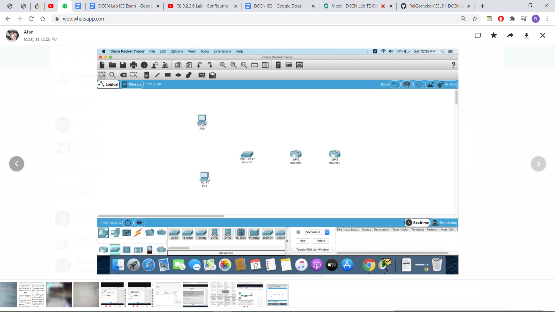

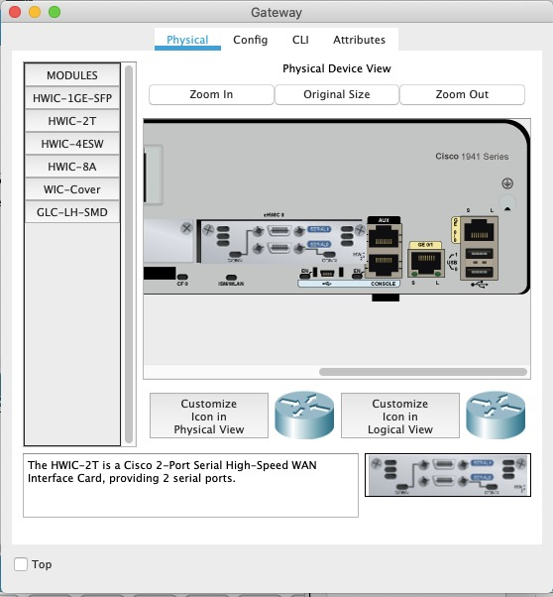

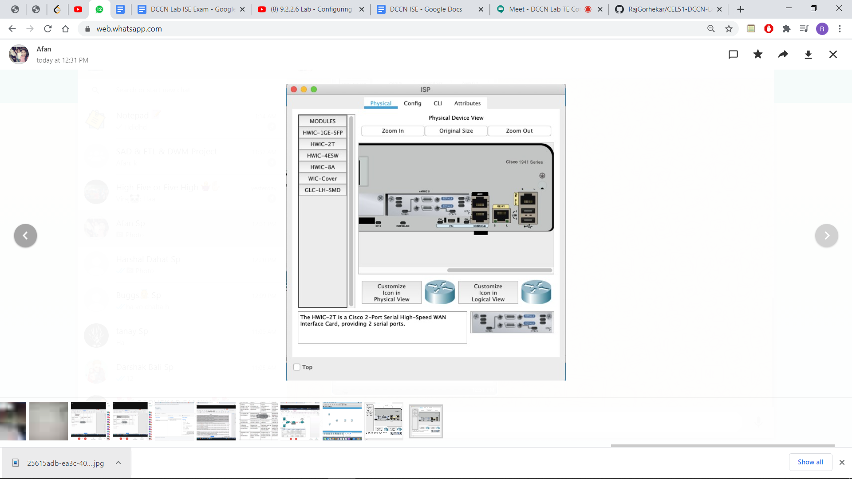

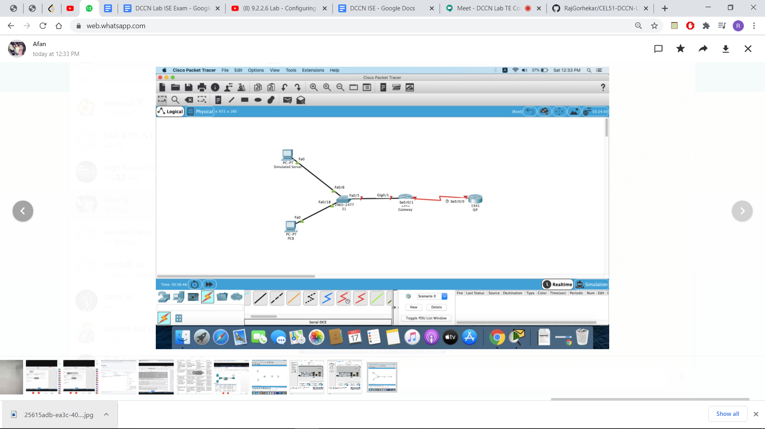

**PC A Configuration**

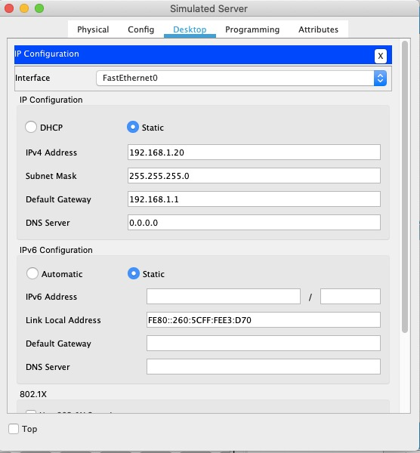

**PC B configuration**

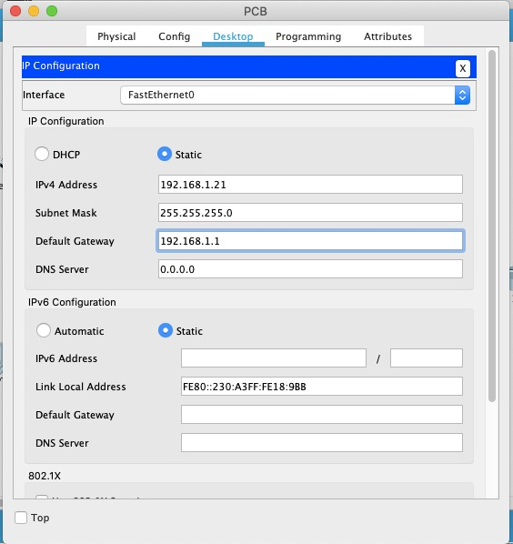

**Configuration for Gateway**

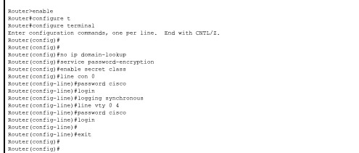

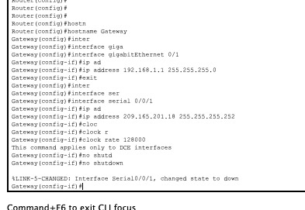

**Configuration for ISP**



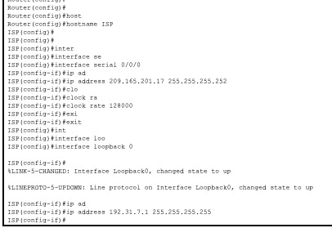

**Create Web Server on Isp**

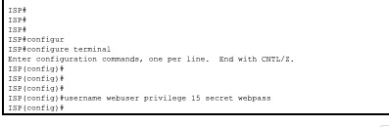

**Configure Static Routing**

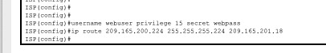

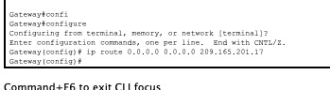

**Running Configuration Start UP**

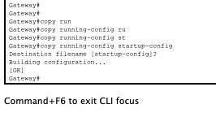

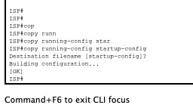

**Testing by Running Ping Command from PC A**

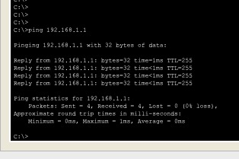

**Testing by Running Ping Command from PC B**

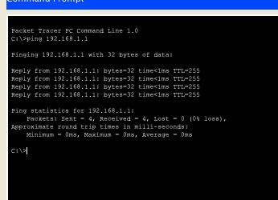

**Displaying Routing Tables**

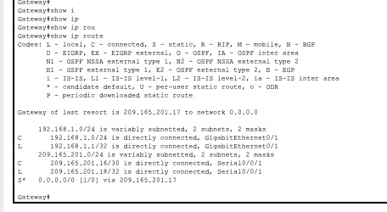

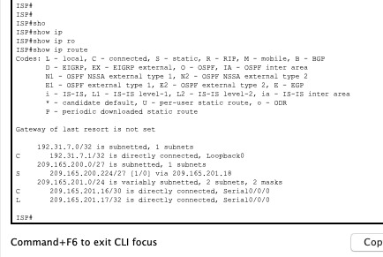

**Task 2**

**Configure static mapping**

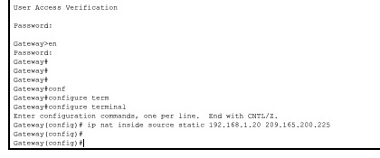

**Specifying the Interface**

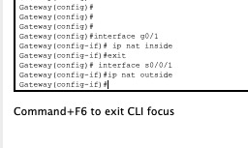

**Testing the Configuration**

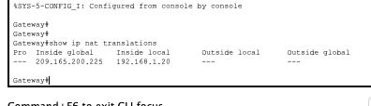

**What is the translation of the Inside local host address?**

**192.168.1.20 = 209.165.200.225**

**The Inside global address is assigned by?**

**ISP**

**The Inside local address is assigned by?**

**Admin**

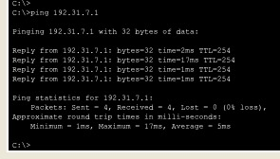

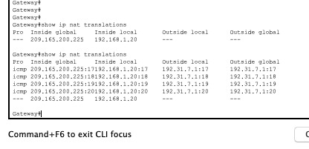

**What port number was used in this ICMP exchange?**

**17,18,19,20**

**Telnet**

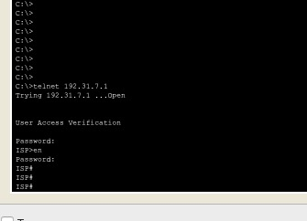

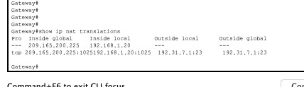

**What was the protocol used in this translation? tcp**

**What are the port numbers used?**

**1025 ,23**

**Inside global / local:**

**209.165.200.225:1025. 192.168.1.20:1025**

**Outside global / local:**

**192.31.7.1:23 192.31.7.1:23**

**Ans d :**

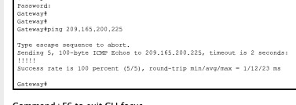

**Ans e :**

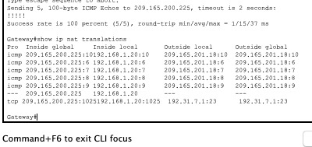

**Ans F:**

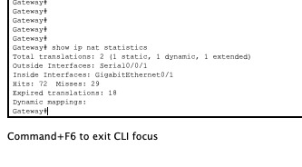

**Task 3**

**Clearing the old translations**

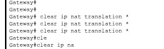

**Ip Nat Stats with 0 Dynamic Entries**

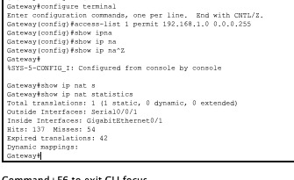

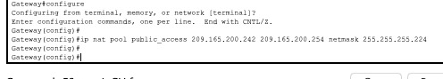

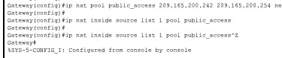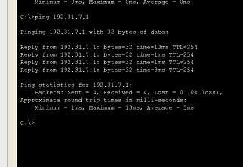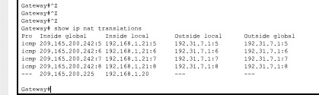

**What is the translation of the Inside local host address for PC-B? 192.168.1.21**

**What port number was used in this ICMP exchange?**

**5 6 7 8**

